- INSTALL ROBOT FRAMEWORK
python -m pip install robotframework

- Run below command to know installed or not

robot --version

OR
NOTE:: -- If you are not installing robot framework through pip please follow below steps
Download tar.gz file form below path
https://pypi.org/project/robotframework/
https://github.com/robotframework/robotframework/releases
- Click on Source code.(zip) to download
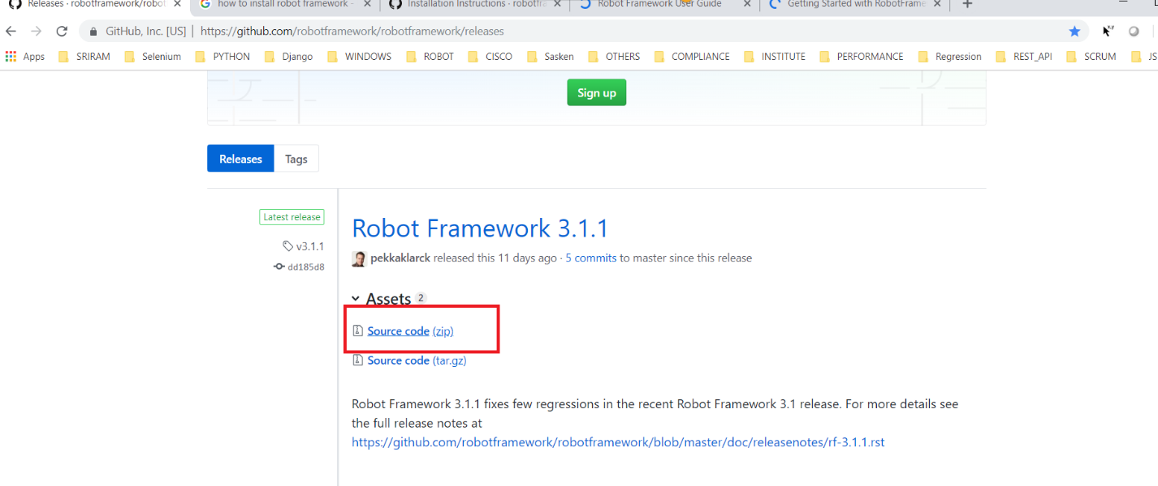

- UNZIP Sourcecode.zip file after unzipping you will see below files

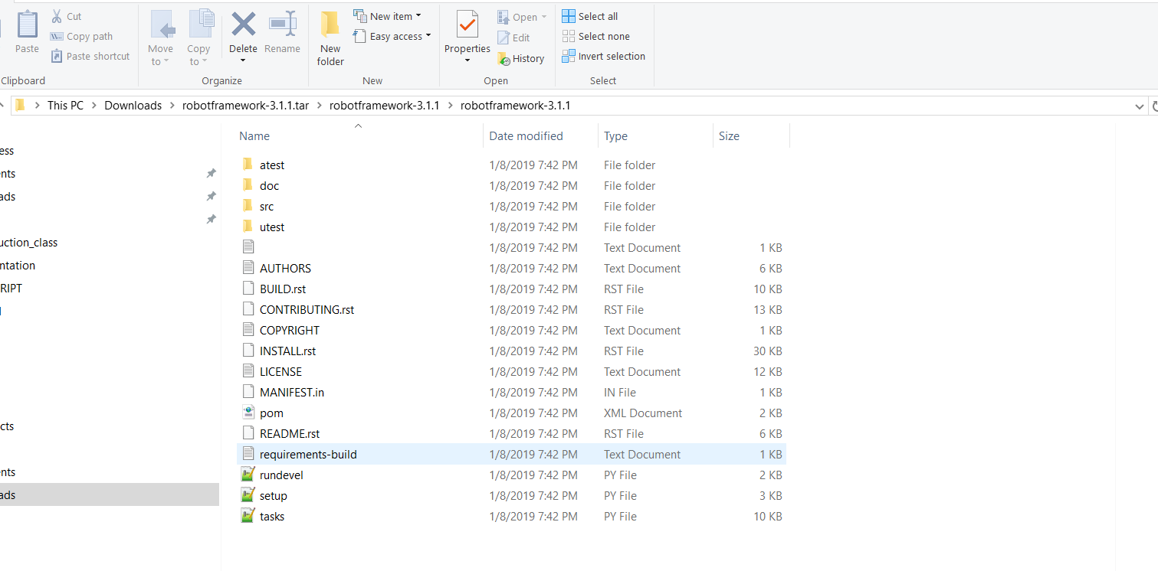

- Then run this command :- python setup.py install

- Run below command to know installed or not

robot --version

